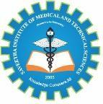

SIMATS ENGINEERING
Saveetha Institute of Medical and Technical Sciences
Chennai- 602105
Student Name: A.Tharun kumar Reddy Reg.;192572068
Course Code: CSA0804
Course Name: Python Programming Slot: D

Course Faculty: Dr. Jegatheesan A

Project Title: Water Distribution and Consumption Management System
Module Photographs:
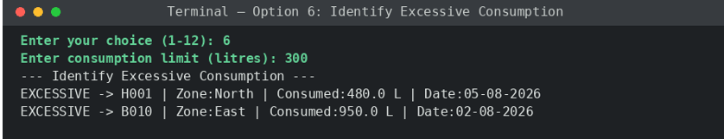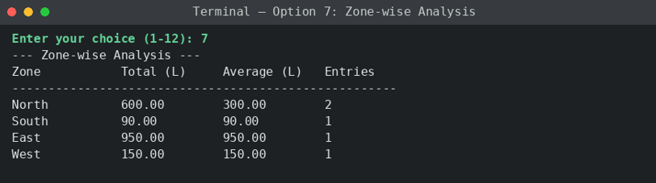
Individual Role:Water Consumption Records and Classification

The water Consumption Records and Classification module is developed to maintain complete and systematic information about the distribution of water to different households or buildings. The system allows the user to enter important details such as Household/Building ID, Area or Zone, quantity of water supplied, quantity of water consumed, and the date of distribution. After entering these details, the system validates the information and stores it as a new water distribution record. The successful addition of a record is confirmed through a message displayed by the system. This module provides an organized way to maintain water distribution information instead of using traditional manual records. The stored data can be used for future reference, monitoring, and analysis. It also helps users understand the relationship between the quantity of water supplied and the quantity consumed. Maintaining these records is important for identifying changes in water demand and ensuring that water is distributed properly among different areas. The module therefore provides a basic foundation for efficient water resource management and helps improve the accuracy and reliability of the overall system.

Student Signature Guide Signature

